

**Evidence Gathering Document for SQA Level 8 Professional Developer Award.**

This document is designed for you to present your screenshots and diagrams relevant to the PDA and to also give a short description of what you are showing to clarify understanding for the assessor.

Each point that required details the Assessment Criteria (What you have to show) along with a brief description of the kind of things you should be showing.

Please fill in each point with screenshot or diagram and description of what you are showing.

**Week 2**

|  |  |  |  |
| --- | --- | --- | --- |
| **Unit** | **Ref** | **Evidence** |  |
| **I&T** | I.T.5 | Demonstrate the use of an array in a program. Take screenshots of:  *An array in a program  *A function that uses the array  *The result of the function running | |
|  |  | **Description:** | |

|  |
| --- |
|  |
| **Here we define a function order_numbers, which takes in a variable and will carry out a sorting method to rearrange the elements of the array to be ascending. (This was created in the Test class)** |
|  |
| **Here we test the function order_numbers on the testarray [2,5,3,4]. The function should rearrange testarray’s order to be [2,3,4,5]** |
|  |
| **From the terminal output we can see the assertion has passed and the function operates as expected.** |

|  |  |  |  |
| --- | --- | --- | --- |
| **Unit** | **Ref** | **Evidence** |  |
| **I&T** | I.T.6 | Demonstrate the use of a hash in a program. Take screenshots of:  *A hash in a program  *A function that uses the hash  *The result of the function running | |
|  |  | **Description:** | |

|  |
| --- |
|  |
| **This is the basic array of customers. It contains 2 entries of hashes** |
|  |
| **This is the function “remove_customer_cash” it takes 2 arguments, person and cost. The 2nd line of code sets a variable “sum_to_remove” equal to the negative of the variable cost. The 3rd line of code returns the entry in @customers which matches the specified “person”. It then updates the :cash key by removing the cost value(sum_to_remove)** |
|  |
| **This shows the test function for remove_customer_cash. When we input a cost of 100 the customer’s cash should reduce from 1000 to 900. As you can see from the terminal image this assertion comes back true.** |

**Week 3**

|  |  |  |  |
| --- | --- | --- | --- |
| **Unit** | **Ref** | **Evidence** |  |
| **I&T** | I.T.3 | Demonstrate searching data in a program. Take screenshots of:  *Function that searches data  *The result of the function running | |
|  |  | **Description:** | |

|  |
| --- |
|  |
| **This is a find function defined within the Hero class of a website. It takes all the information for the database on a particular hero where the id matches the search id.** |
|  |
| **This is where the viewer calls on the find function to display a page for a specific hero(id).** |
|  |
| **This is the output of the view page, it displays all the information on the hero with id 2.** |

|  |  |  |  |
| --- | --- | --- | --- |
| **Unit** | **Ref** | **Evidence** |  |
| **I&T** | I.T.4 | Demonstrate sorting data in a program. Take screenshots of:  *Function that sorts data  *The result of the function running | |
|  |  | **Description:** | |

|  |
| --- |
|  |
| **defining the function all_true for the Hero Class. this selects from the database all the information from the heroes table on the condition where hireable = true. This is used to restrict/sort the list of all heroes down to just ones that are hireable.** |
|  |
| **This function is called in the join table (hero_teams) controller, for the new view. it is carried out on the @heroes variable which goes through all the heroes in the heroes table and gives the user only the heroes which are hireable.** |
|  |
| **This shows where the reduced hero list is used in the new view form. It is a dropdown list that shows each heroes name.** |
|  |
| **Here we can see the resulting interface on the website. The 4 heroes listed are the from the heroes table where their hireable status is equal to true.** |

**Week 5 and 6**

|  |  |  |  |
| --- | --- | --- | --- |
| **Unit** | **Ref** | **Evidence** |  |
| **A&D** | A.D.1 | A Use Case Diagram | |
|  |  | **Description:** | |

[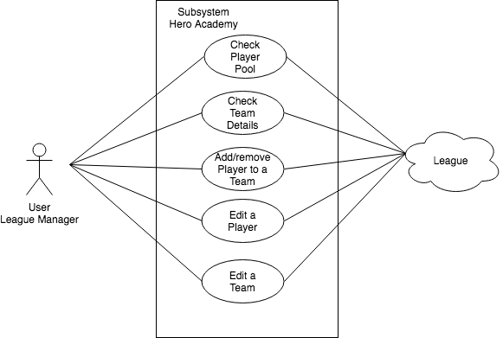](https://www.draw.io/#G12zTVdYTJELatyx538YwznHbEyE77LflO)

**This Case diagram shows the user which is the league manager and the functions that the subsystem Hero academy app needs to be able to perform.**

|  |  |  |  |
| --- | --- | --- | --- |
| **Unit** | **Ref** | **Evidence** |  |
| **A&D** | A.D.2 | A Class Diagram | |
|  |  | **Description:** | |

[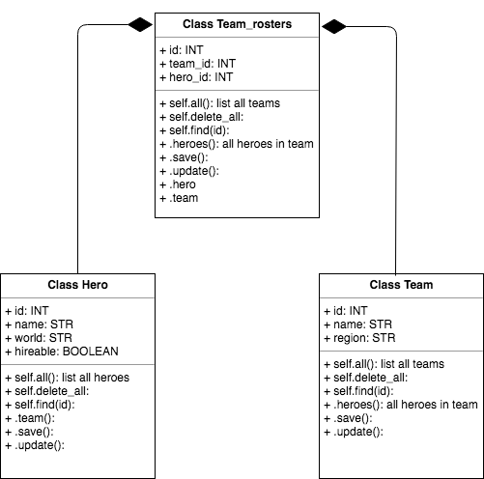](https://www.draw.io/#G1SD--vxqSGNbf9vfih_SDQEc0GtGtu6ze)

**This class diagram shows the three classes that are required for the hero_academy app. The class Hero and class Team contain several properties outside their id’s, and many functions. Both class’ feed into the class Team_rosters which only contains properties of the id of the other classes. It contains several functions**

|  |  |  |  |
| --- | --- | --- | --- |
| **Unit** | **Ref** | **Evidence** |  |
| **A&D** | A.D.3 | An Object Diagram | |
|  |  | **Description:** | |

[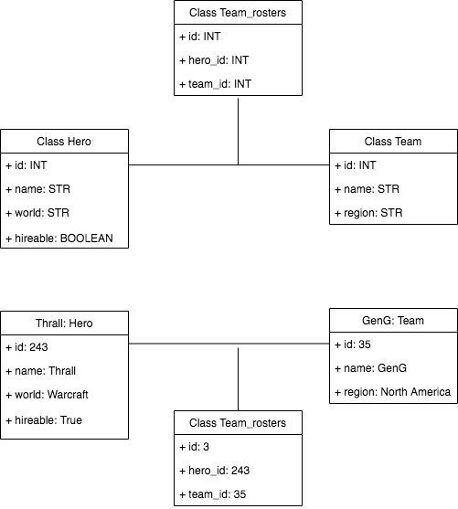](https://www.draw.io/#G13aqjgMZtgtuA8MhMvI1qi0rodcAZRGKq)

**This object diagram shows an example of what a Hero would be, a Team and how the Team_rosters information relates between the two.**

|  |  |  |  |
| --- | --- | --- | --- |
| **Unit** | **Ref** | **Evidence** |  |
| **A&D** | A.D.4 | An Activity Diagram | |
|  |  | **Description:** | |

[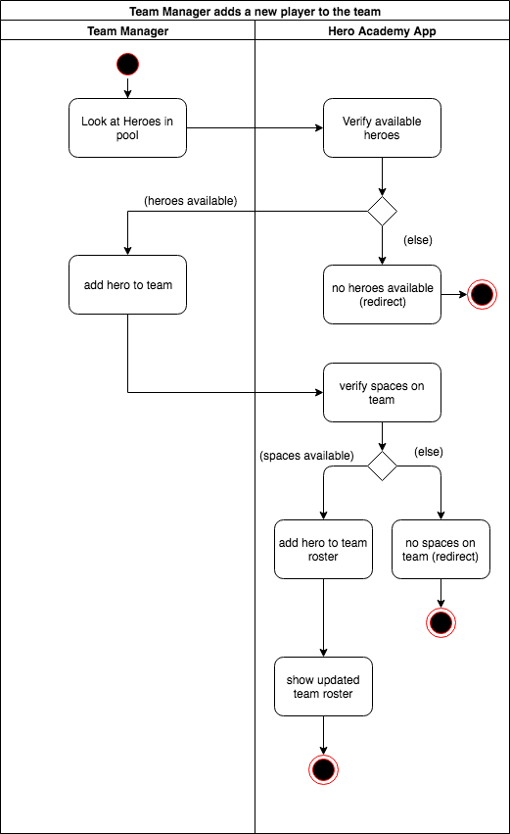](https://www.draw.io/#G1YNbeMjMw7Y4PJb8J9B9Dq10Ztw4ONxE8)

**This activity diagram shows the activity of adding a new hero to a team’s roster. The flow shows the steps that the manager might take and the sort of responses and process the Hero Academy app would need to carry out to fulfill those needs.**

|  |  |  |  |
| --- | --- | --- | --- |
| **Unit** | **Ref** | **Evidence** |  |
| **A&D** | A.D.6 | Produce an Implementations Constraints plan detailing the following factors:  *Hardware and software platforms  *Performance requirements  *Persistent storage and transactions  *Usability  *Budgets  *Time | |
|  |  | **Description:** | |

|  |  |  |
| --- | --- | --- |
| **Constraint Category** | **Implementation Constraint** | **Solution** |
| Hardware and software platforms | users using different web browsers, compatibility issues with the designed app | carrying out testing of the app on each platform, altering back end to compensate for any errors. |
| Performance requirements | bandwidth of user | ensure the app is built efficiently, no large downloads |
| Persistent storage and transactions | not enough storage space on server for all user information | buy additional server space/servers if required |
| Usability | app is very visual, not being usable by the visually impaired | ensure usability is coded in from the beginning so all users can use the app |
| Budgets | enough money to pay programmers | project manage the app development to ensure the budget lasts the duration |
| Time | lose market share by releasing too late, another developer release a competitive app | project manage the app development to ensure the app releases in a set time frame. Know when to cut off features relative to release |

|  |  |  |  |
| --- | --- | --- | --- |
| **Unit** | **Ref** | **Evidence** |  |
| **P** | P.5 | User Site Map | |
|  |  | **Description:** | |

[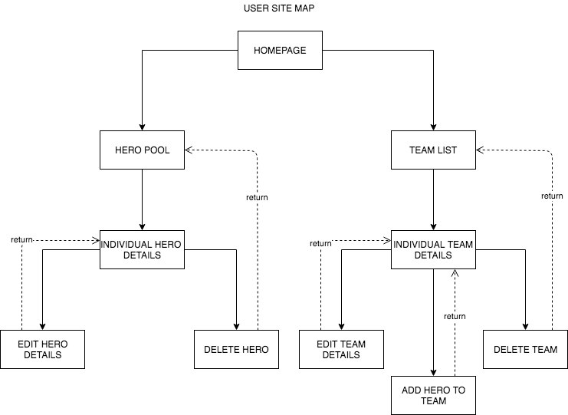](https://www.draw.io/#G1pQ7iZrweWRiM2x9ubzql7BMu_gd0cIRj)

This user map shows the layout of the website hero_academy. It demonstrates how the user can navigate across the individual pages and how the pages will return the user to previous pages once their function is completed.

|  |  |  |  |
| --- | --- | --- | --- |
| **Unit** | **Ref** | **Evidence** |  |
| **P** | P.6 | 2 Wireframe Diagrams | |
|  |  | **Description:** | |

[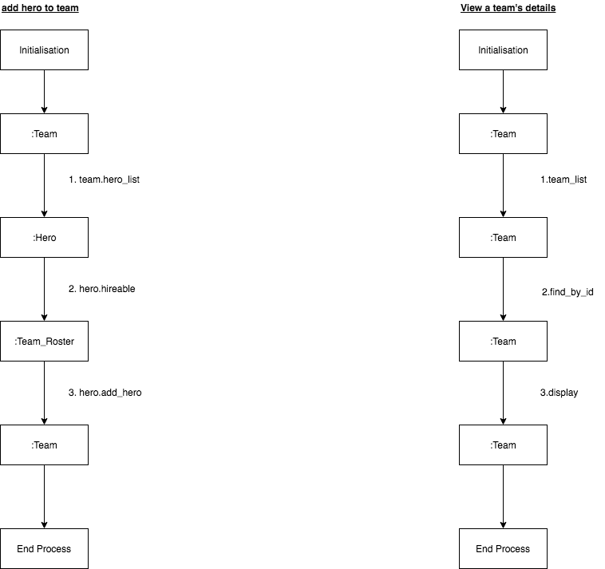](https://www.draw.io/#G17vwQXVGR2mPYja_f-vvUZZbR0JHrbVKD)

There are 2 wireframes here of the collaboration diagram type.

The 1 on the left is for **adding a hero to a team.**

* step one calls the method hero_list to grab all of the heroes.
* step two calls the method hireable to filter the list of heroes to only ones that are hireable.
* step three call the method add_hero which adds the hero to the team in the join table Team_Roster.

The 1 on the right is for **viewing a Team’s details.**

* step one call the method team_list to grab all of the teams.
* step two calls the method find_by_id to find all of the information on the specific team.
* step three calls the method display which displays the information on the specific hero.

|  |  |  |  |
| --- | --- | --- | --- |
| **Unit** | **Ref** | **Evidence** |  |
| **P** | P.10 | Example of Pseudocode used for a method | |
|  |  | **Description:** | |

**Paste Screenshot here**

**Description here**

|  |  |  |  |
| --- | --- | --- | --- |
| **Unit** | **Ref** | **Evidence** |  |
| **P** | P.13 | Show user input being processed according to design requirements. Take a screenshot of:  * The user inputting something into your program  * The user input being saved or used in some way | |
|  |  | **Description:** | |

|  |
| --- |
|  |
| **This is the form for adding a new hero to the academy. It has two text fields for the user to fill in and one radial button to choose from.** |
|  |
| **This is the form filled in by the user** |
|  |
| **This is the resulting information produced by submitting the add hero form, displayed on the list of heroes page.** |
|  |
| **This is the individual hero’s detail page, you can see all the information that was entered about the new hero ‘Ragnaros’ entered by the user.** |

|  |  |  |  |
| --- | --- | --- | --- |
| **Unit** | **Ref** | **Evidence** |  |
| **P** | P.14 | Show an interaction with data persistence. Take a screenshot of:  * Data being inputted into your program  * Confirmation of the data being saved | |
|  |  | **Description:** | |

|  |
| --- |
|  |
| **This is the starting point for the team list of the website and the corresponding postico/server information for the teams table.** |
|  |
| **This is the form for adding a new team, it has been filled in with information** |
|  |
| **This is the resulting display for the team list on the website, ‘Red Lobsters’ have now been added to the list. The data has also been saved to postico/server under id:3.** |

|  |  |  |  |
| --- | --- | --- | --- |
| **Unit** | **Ref** | **Evidence** |  |
| **P** | P.15 | Show the correct output of results and feedback to user. Take a screenshot of:  * The user requesting information or an action to be performed  * The user request being processed correctly and demonstrated in the program | |
|  |  | **Description:** | |

|  |
| --- |
|  |
| **The homepage of the website. The user selects the “Teams” button** |
|  |
| **Which takes them to a list of all Teams. Selecting the 1st team “GenG” link** |
|  |
| **We see all of the team’s data, including the table containing the hero’s associated with that specific team.** |
|  |
| **Here we can see all of the heroes in the hero pool, those hired and those available for hire. Looking at the id’s Jaina is 5, Kael’thas is 6 and Kerrigan is 7.** |
|  |
| **When we look at the join table “hero_teams” we can see that for team GenG (team_id =1) the correct heroes should 5, 6 and 7 which is what the table on the Team details page displays.** |

|  |  |  |  |
| --- | --- | --- | --- |
| **Unit** | **Ref** | **Evidence** |  |
| **P** | P.11 | Take a screenshot of one of your projects where you have worked alone and attach the Github link. | |
|  |  | **Description:** | |

|  |
| --- |
|  |
| **Github link; https://github.com/Castlecelts/Ruby_Project** |

|  |  |  |  |
| --- | --- | --- | --- |
| **Unit** | **Ref** | **Evidence** |  |
| **P** | P.12 | Take screenshots or photos of your planning and the different stages of development to show changes. | |
|  |  | **Description:** | |

|  |
| --- |
|  |
| **This is where the project began, creating some wireframes for each web page with basic functionality for each.** |
|  |
| **This was the 2nd step in planning, thinking about what each database table would contain. As you can see the name of the join table altered during the project from “Team_roster” to “Hero_teams” based off a formatting suggestion.** |
|  |
| **A later step in the planning was to map how each web page would interact with others. the controllers that needed to be in place to run those pages and interactions and what the url for each page would be. This was particularly relevant for the add hero to team roster page as it was accessed from a “Team” page but would be updating the join table information.**  **This step in the planning was near how the finished project ended.** |

**Week 7**

|  |  |  |  |
| --- | --- | --- | --- |
| **Unit** | **Ref** | **Evidence** |  |
| **P** | P.16 | Show an API being used within your program. Take a screenshot of:  * The code that uses or implements the API  * The API being used by the program whilst running | |
|  |  | **Description:** | |

|  |  |  |  |
| --- | --- | --- | --- |
| **Unit** | **Ref** | **Evidence** |  |
| **P** | P.18 | Demonstrate testing in your program. Take screenshots of:  * Example of test code  * The test code failing to pass  * Example of the test code once errors have been corrected  * The test code passing | |
|  |  | **Description:** | |

|  |  |
| --- | --- |
|  |  |
| **Initial Code** | **Finished Code** |

|  |
| --- |
|  |
| **Running spec file, no assertions** |
|  |
| **checkforace true failing** |
|  |
| **checkforace true passing** |
|  |
| **checkforace false passing** |
|  |
| **checkhighest where card1 is higher failing** |
|  |
| **checkhighest where card1 is higher passing** |
|  |
| **checkhighest where card2 is higher passing** |
|  |
| **checkhighest where card1 equals card2 passing** |
|  |
| **cardstotal on an array of 2 cards failing** |
|  |
| **cardstotal on an array of 2 cards passing** |
|  |
| **cardstotal on an empty array passing** |

|  |  |
| --- | --- |
|  |  |
| **Final testing spec code (page1)** | **Final testing spec code (page2)** |

**Week 9**

|  |  |  |  |
| --- | --- | --- | --- |
| **Unit** | **Ref** | **Evidence** |  |
| **P** | P.1 | Take a screenshot of the contributor’s page on Github from your group project to show the team you worked with. | |
|  |  | **Description:** | |

**Paste Screenshot here**

**Description here**

|  |  |  |  |
| --- | --- | --- | --- |
| **Unit** | **Ref** | **Evidence** |  |
| **P** | P.2 | Take a screenshot of the project brief from your group project. | |
|  |  | **Description:** | |

**Paste Screenshot here**

**Description here**

|  |  |  |  |
| --- | --- | --- | --- |
| **Unit** | **Ref** | **Evidence** |  |
| **P** | P.3 | Provide a screenshot of the planning you completed during your group project, e.g. Trello MOSCOW board. | |
|  |  | **Description:** | |

**Paste Screenshot here**

**Description here**

|  |  |  |  |
| --- | --- | --- | --- |
| **Unit** | **Ref** | **Evidence** |  |
| **P** | P.4 | Write an acceptance criteria and test plan. | |
|  |  |  | |

**Paste Screenshot here**

**Description here**

|  |  |  |  |
| --- | --- | --- | --- |
| **Unit** | **Ref** | **Evidence** |  |
| **P** | P.7 | Produce two system interaction diagrams (sequence and/or collaboration diagrams). | |
|  |  | **Description:** | |

**Paste Screenshot here**

**Description here**

|  |  |  |  |
| --- | --- | --- | --- |
| **Unit** | **Ref** | **Evidence** |  |
| **P** | P.8 | Produce two object diagrams. | |
|  |  | **Description:** | |

**Paste Screenshot here**

**Description here**

|  |  |  |  |
| --- | --- | --- | --- |
| **Unit** | **Ref** | **Evidence** |  |
| **P** | P.17 | Produce a bug tracking report | |
|  |  | **Description:** | |

**Paste Screenshot here**

**Description here**

**Week 12**

|  |  |  |  |
| --- | --- | --- | --- |
| **Unit** | **Ref** | **Evidence** |  |
| **I&T** | I.T.7 | The use of Polymorphism in a program and what it is doing. | |
|  |  | **Description**: | |

**Paste Screenshot here**

**Description here**

|  |  |  |  |
| --- | --- | --- | --- |
| **Unit** | **Ref** | **Evidence** |  |
| **A&D** | A.D.5 | An Inheritance Diagram | |
|  |  | **Description:** | |

**Paste Screenshot here**

**Description here**

|  |  |  |  |
| --- | --- | --- | --- |
| **Unit** | **Ref** | **Evidence** |  |
| **I&T** | I.T.1 | The use of Encapsulation in a program and what it is doing. | |
|  |  | **Description:** | |

**Paste Screenshot here**

**Description here**

|  |  |  |  |
| --- | --- | --- | --- |
| **Unit** | **Ref** | **Evidence** |  |
| **I&T** | I.T.2 | Take a screenshot of the use of Inheritance in a program. Take screenshots of:  *A Class  *A Class that inherits from the previous class  *An Object in the inherited class  *A Method that uses the information inherited from another class. | |
|  |  | **Description:** | |

**Paste Screenshot here**

**Description here**

|  |  |  |  |
| --- | --- | --- | --- |
| **Unit** | **Ref** | **Evidence** |  |
| **P** | P.9 | Select two algorithms you have written (NOT the group project). Take a screenshot of each and write a short statement on why you have chosen to use those algorithms. | |
|  |  | **Description:** | |

**Paste Screenshot here**

**Description here**

[](https://www.draw.io/#G1SD--vxqSGNbf9vfih_SDQEc0GtGtu6ze)